How to connect SP3 to google home.
This Guide is showed you the process on how to connect your Tenda Beli device to your Google Home, please make sure your Google Home is setup already.
Before we start, please make sure Remote Control of your Tenda Beli device is enabled on your Beli APP.
Step 1: Log into Google Home App. Click the “” on the left lower corner.
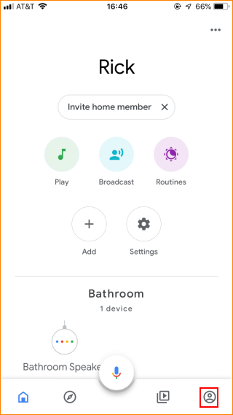
Step 2: Tap “More Settings”
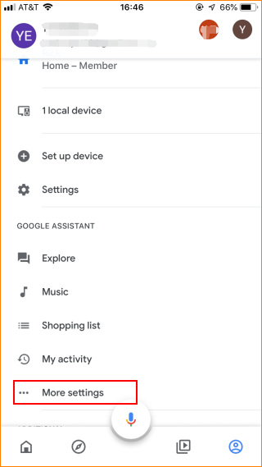
Step 3: Tap “Assistant”.
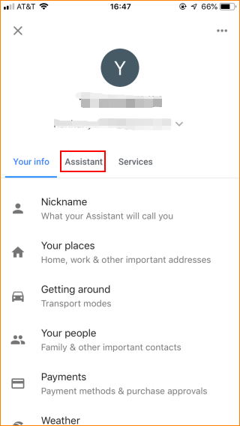
Step 4: Tap “Home control”.
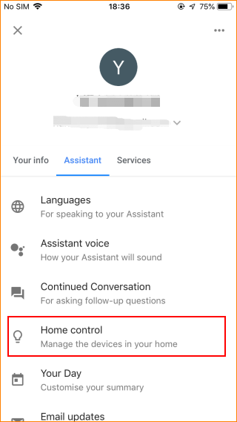
Step 5: Tap “” on the right upper corner
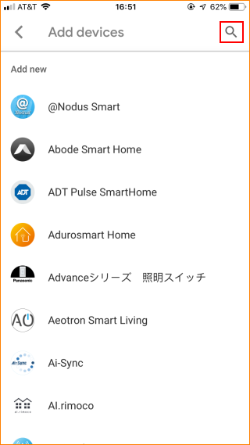

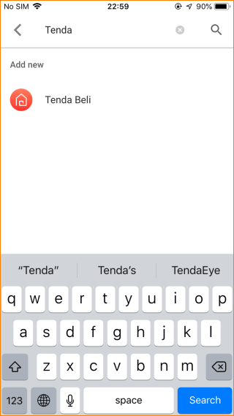
Step 6: Login with your Tenda Beli.
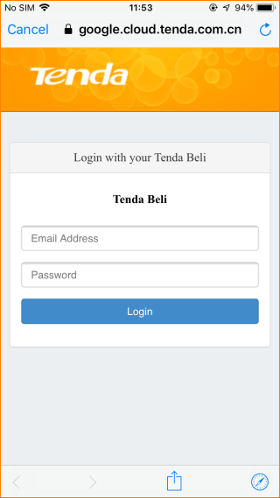
Step 7: Choose the device.
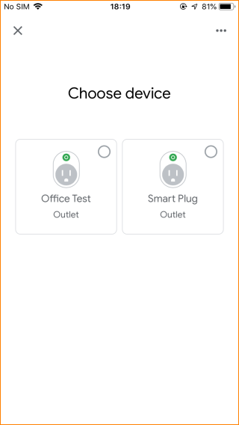
Step 8: Under the devices you can see the device which is linked to the Google Home.
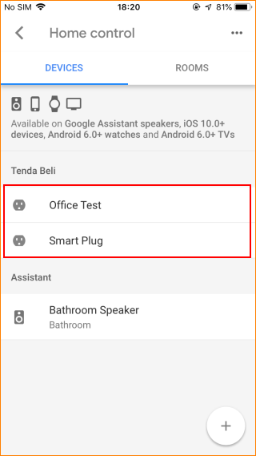
And you can see the linked device in the main page.
